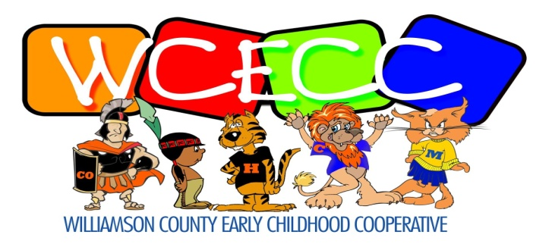
618-993-2138 411 S. Court Street 618-997-3950
Phone Marion, IL 62959 FAX

Jami Hodge, Director Jaci Crain, Coordinator
______________________________________________________________________________

PUBLIC NOTICE OF MEETING

The Executive Committee of Williamson County Early Childhood Cooperative will hold a regular quarterly meeting on Friday, October 16, 2023 at 8:30 a.m., WCES Conference Room, 411 S Court Street, Marion, IL 62959

